**STAIR CLIMBING WITH LOAD**

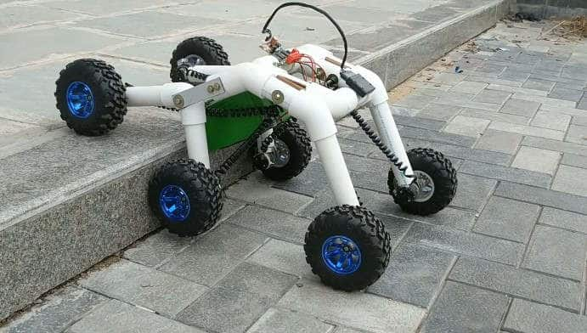

## 

## About

|  |
| --- |
| In today’s life , technology concerned with the robots plays important role in many fields because they are used to operate in hazardous and urban environments. Some of the robots are designed to operate only on natural terrains , but it can also be used for rough terrains and artificial environments including **STAIRWAYS.**  Until recent years, the stair climbing robots were designed with vast hardware and robots were equipped with chain roller to climb stairs or to move on a ﬂat surface. The mechanical design of the this robot contains the ﬁxed and ﬂexible links of **WHEEL** legs instead of chain roller.  The bot is moving on its six wheels powered by high torque DC motors which enables it to climb up the stair with an ease. The bot is equipped with a self adjusting plate on its top(just like a camera gimbal) which helps to keep the load always in horizontal position.  The rear arms are rigid while the front arm (basically an elbow joint) is flexible and free to rotate about a horizontal axis thus enabling the front part to get lifted up whenever it encounter a stair. The bot is manually controlled by node MCU.  Team consist of 8 dedicated and passionate members always ready to learn new thing through experimental approach. The team is working under the mentorship of **VINEET SINGLA** (Mech. Dept.) Other members are first year B.tech students from different disciples.  This project is definitely going to be highly beneficial for society when used in its full potential. Of course it can perform some usual tasks like carrying stuffs up and down but with some modifications it can be highly helpful for physically challenged people for moving up and down in buildings especially those which don’t have lifts installed in them which is generally not installed in smaller buildings. |

## Impact

|  |
| --- |
| **ACHIEVEMENTS-**  **1**.The project is in working phase.  **2**. A balancing plate has been installed which remains horizontal always even during the time of climbing stair thus keeping the load in place.  **3**. It is faster than its previous counterparts which used joint legs for climbing.  **LEARNINGS-**  **1.**Learned a lot about structures and their stabilities.  **2.**Got to learn a lot of mechanical skills like cutting, drilling etc.  **3.** Learned about electrical connections, and electronic chips and stuff like Aurdino, Node MCU  **4.** Learned a lot of things while coding for balancing plate .  **5.** And above all we learned to work together as a team. |

## Contact

|  |
| --- |
| **CLUB NAME: Robotics club**  **TEAM:**   1. **MENTOR** - Vineet Singla (vineetsingla39@gmail.com) 2. Himanshu Singh (himanshusingh1301@gmail.com) 3. Maitri Khanna ([khanna.maitri029@gmail.com](mailto:khanna.maitri029@gmail.com)) 4. Utkarsh Kumar ([kutkarsh460@gmail.com](mailto:kutkarsh460@gmail.com)) 5. Jatin Dhingra ([jatindhingra009@gmail.com](mailto:jatindhingra009@gmail.com)) 6. Shridham Mahajan ([shridham.mahajan@gmail.com](mailto:shridham.mahajan@gmail.com)) 7. Suman kumari Sinha (sumankumari1818@gmail.com) 8. Ankita singh |